|  |  |  |
| --- | --- | --- |
| **EX NO : 01** | **Device ON / OFF using PIC 16F877A microcontroller (Relay and LED)** | **Batch No : 02** |
| **DATE : 16/07/2025** | **Roll No : 23ECR117** |

**AIM :**

* To blink an LED using the PIC16F877A microcontroller to demonstrate basic digital output control.
* To control a fan or light by switching a relay ON or OFF using a switch and the PIC16F877A microcontroller.

**Software Required :**

* PIC C Compiler to compile and create hex file.
* PICkit 2 programmer for burning the hex file to PIC microcontroller.
* Proteus 8.17 is used for the simulation of circuits.

**Apparatus Required :**

|  |  |  |  |
| --- | --- | --- | --- |
| **Sl. No** | **Apparatus name** | **Range** | **Quantity** |
| 1. | Bread board | - | 1 |
| 2. | Regulated Power Supply | 5V, 2A | 1 |
| 3. | PIC16F877A | 40 - Pin PDIP | 1 |
| 4. | Crystal oscillator | 4 MHz | 1 |
| 5. | PIC programmer and USB cable | - | 1 |
| 6. | Light Emitting Diode (LED) | - | 1 |
| 7. | Switch | SPST / SPDT | 1 |
| 8. | Relay | 12V / 5V | 1 |
| 9. | BC547 - NPN Transistor | - | 1 |
| 10. | Diode | 1N4001 | 1 |
| 11. | Resistor | 330 Ω,1k Ω | 2 Each |
| 12. | Connecting wires | Single strand | As required |

**Procedure :**

* Open PIC C Compiler (CCS).
* Create a New Project using the Project Wizard.
* Select PIC16F877A from the PIC16 family.
* Set the crystal frequency to 4 MHz.
* Select the I/O pins and define each as Input, Output, Input/Output, or None as required.
* In the Fuses settings, tick the checkbox for Power-up Timer.
* Write the required C code and save the project.
* Click Build/Compile to generate the .hex file.
* Open Proteus, design the circuit with PIC, LED, switch, relay, etc.
* Double-click the PIC in Proteus and load the compiled .hex file.
* Click Run to simulate and observe the output.

1. **Blinking of LED using PIC 16F877A Microcontroller :**

**Code :**

#include <16F877A.h>

#device ADC=16

#FUSES NOWDT                    //No Watch Dog Timer

#FUSES PUT                      //Power Up Timer

#FUSES NOBROWNOUT               //No brownout reset

#FUSES NOLVP                    //No low voltage prgming, B3(PIC16) or B5(PIC18) used for I/O

#use delay(crystal=4MHz)

#use FIXED_IO( B_outputs=PIN_B0 )

#define LED   PIN_B0

void main()

{

   while(TRUE)

   {

     output_high(LED);

      delay_ms(100);

      output_low(LED);

      delay_ms(100);

   }

}

**Simulation output :**

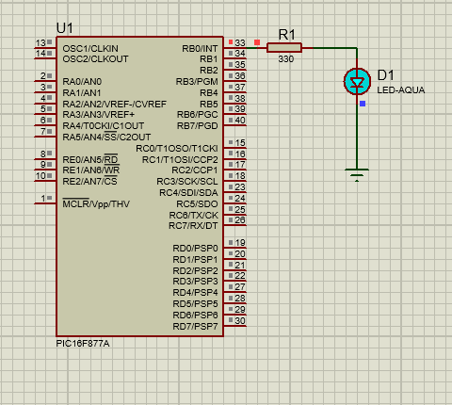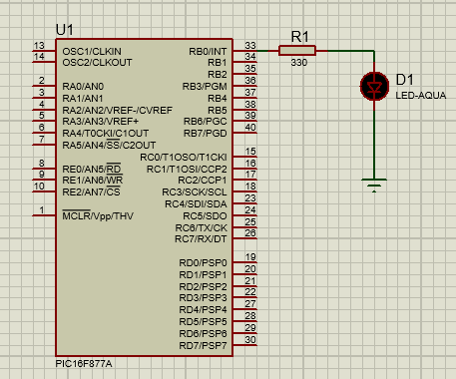

**Hardware Output :**

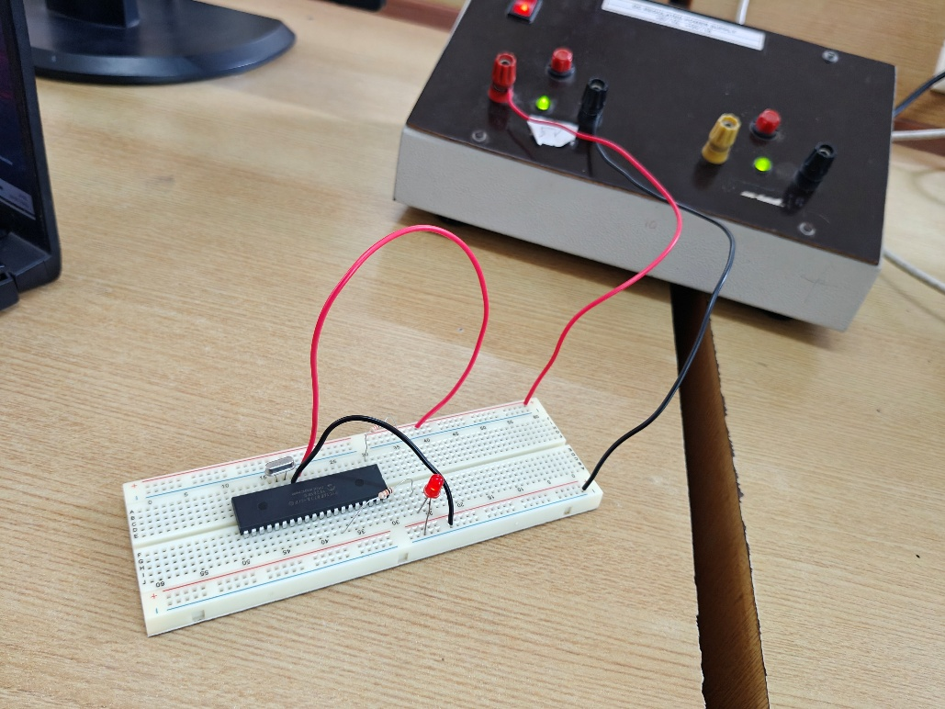

1. **LED ON/OFF using Relay :**

**Code :**

#include <16F877A.h>

#device ADC=16

#FUSES NOWDT                    //No Watch Dog Timer

#FUSES PUT                      //Power Up Timer

#FUSES NOBROWNOUT               //No brownout reset

#FUSES NOLVP                    //No low voltage prgming, B3(PIC16) or B5(PIC18) used for I/O

#use delay(crystal=4MHz)

#use FIXED_IO( B_outputs=PIN_B0 )

#define LED   PIN_B0

#define SWITCH1   PIN_D0

void main()

{

   while(TRUE)

   {

     if (input(SWITCH1) == 0)

         output_low(LED);

      else

         output_high(LED);

   }

}

**Simulation output :**

**Hardware Output :**

**QR Code:**

1. Led Blink : 2) Relay :

|  |  |  |
| --- | --- | --- |
| **Rubrics** | | **Marks** |
| **Conduct of Experiment (20)** | Analyse the problem and develop programming constructs (15) |  |
| Completeness of the experiment (5) |  |
| **Observation/ Record (30)** | Interpretation of the findings (15) |  |
| Simulation and Hardware (5) |  |
| Adherence to record submission deadline (5) |  |
| Presentation and completion of record (5) |  |
| **Viva (10)** | Ability to recall the theoretical concepts |  |
| **Total (60)** | |  |

**Result :**

Thus the Device ON / OFF using PIC 16F877A microcontroller (Relay and LED) was is done successfully by using PIC C Compiler and Proteus Software 8.17.